https://cloud.google.com/vision/docs/detecting-web

export GOOGLE_APPLICATION_CREDENTIALS=“ECET Senior Project-8fedbaaddc95.json”

<https://www.dexterindustries.com/howto/use-google-cloud-vision-on-the-raspberry-pi/>

Unix password pi = bluebatteryglass

<http://www.brightsparks.org.nz/userfiles/file/Raspberry_Pi_Guide%20(1).pdf>

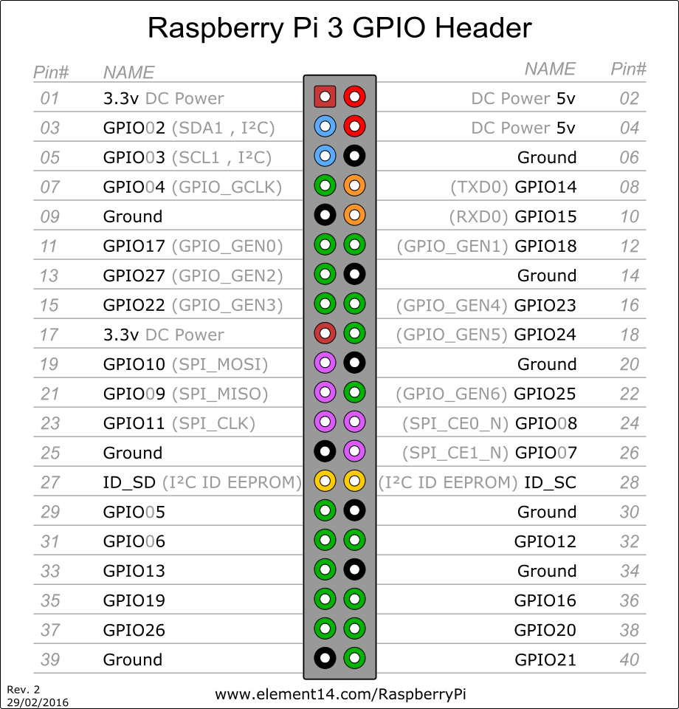

This is for the BOARD layout

Odd rows are facing the raspberry pi symbol, closest to

<https://tutorials-raspberrypi.com/how-to-control-a-stepper-motor-with-raspberry-pi-and-l293d-uln2003a/>

Carton

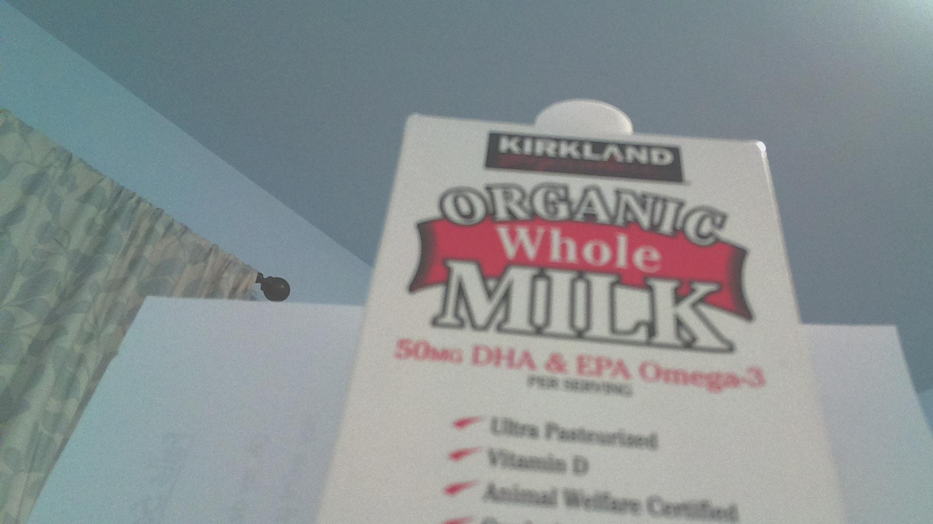

Label:

{

"responses": [

{

"labelAnnotations": [

{

"description": "text",

"mid": "/m/07s6nbt",

"score": 0.8859538

},

{

"description": "font",

"mid": "/m/03gq5hm",

"score": 0.75462013

},

{

"description": "brand",

"mid": "/m/01cd9",

"score": 0.5637506

},

{

"description": "advertising",

"mid": "/m/011s0",

"score": 0.55129117

},

{

"description": "product",

"mid": "/m/01jwgf",

"score": 0.54658276

}

]

}

]

}

Vs

Webdetection

As you can see not having the cover + upping brightness changed a LOT

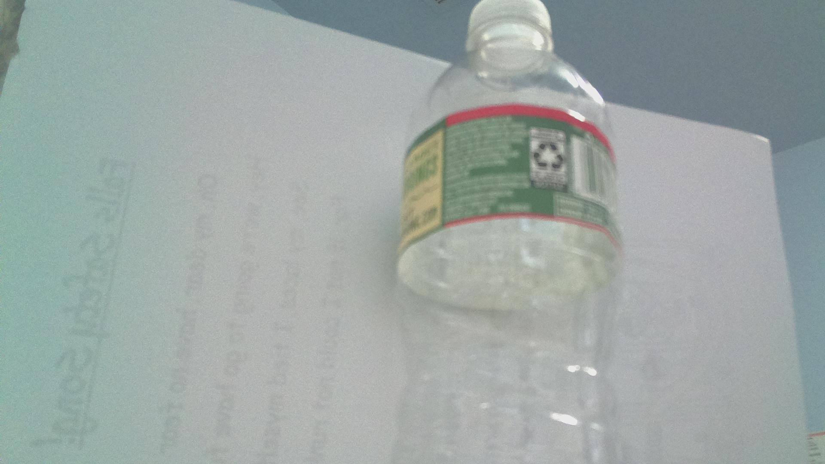

{

"responses": [

{

"labelAnnotations": [

{

"description": "water",

"mid": "/m/0838f",

"score": 0.9470656

},

{

"description": "bottle",

"mid": "/m/04dr76w",

"score": 0.7374425

},

{

"description": "glass bottle",

"mid": "/m/089mxq",

"score": 0.686556

},

{

"description": "plastic bottle",

"mid": "/m/02rlncx",

"score": 0.6713728

},

{

"description": "product",

"mid": "/m/01jwgf",

"score": 0.6647938

},

{

"description": "glass",

"mid": "/m/039jq",

"score": 0.63673264

},

{

"description": "drinkware",

"mid": "/m/050h26",

"score": 0.600894

},

{

"description": "liquid",

"mid": "/m/04k94",

"score": 0.5135493

}

]

}

]

}

-------------------------------

Here is web detection

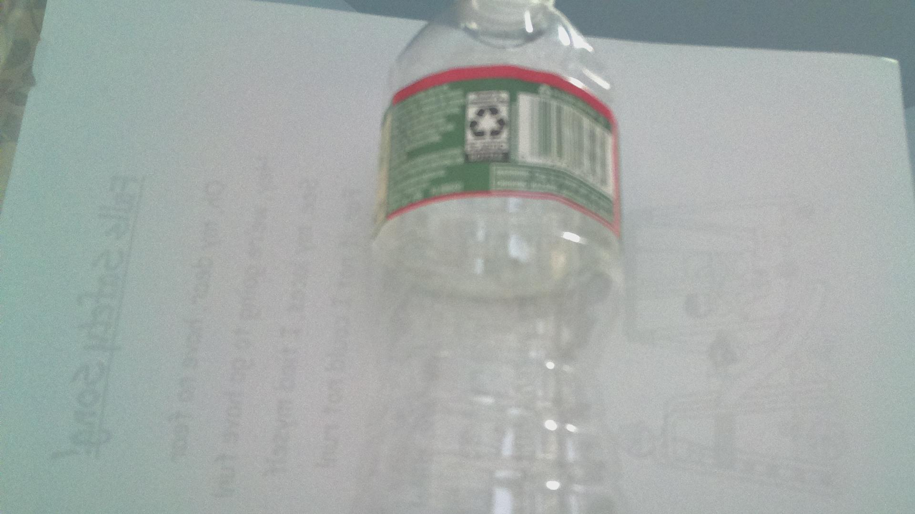

{

"responses": [

{

"webDetection": {

"visuallySimilarImages": [

{

"url": "http://www.civildefensemuseum.com/cdmuseum2/supply/water/liners.jpg"

},

{

"url": "https://www.extremetech.com/wp-content/uploads/2016/08/ncd-640x353.jpg"

},

{

"url": "http://laurelleaffarm.com/item-photos/vintage-glass-pharmacy-medicine-bottle-embossed-Wyeth-hospital-use-halfpint-jar-Laurel-Leaf-Farm-item-no-z210104-6.jpg"

},

{

"url": "https://2.bp.blogspot.com/-sRxMY1tHfAc/VrjbPk-VnLI/AAAAAAAAC6w/yfq2HciqdgY/s1600/CatriceLiquidCamouflageConcealerLightNatural5.JPG"

},

{

"url": "http://laurelleaffarm.com/item-photos/frosted-poppies-clear-satin-glass-vase-ebony-black-glass-stand-vintage-Tiffin-or-Imperial-Laurel-Leaf-Farm-item-no-s111035-5.jpg"

},

{

"url": "http://www-tc.pbs.org/prod-media/antiques-roadshow/__sized__/Images/SanDiego_20010630_01/200103A40/IMG0072-crop-c0-35__0-39-400x225.jpg"

},

{

"url": "https://i.pinimg.com/736x/74/42/03/744203a7b472adce83b87cf4ec8c0b3d--milk-glass-shells.jpg"

},

{

"url": "https://i.pinimg.com/736x/66/b2/44/66b244bfc18490166d3b8d8aecf5fe7c--milk-bottles-glass-jars.jpg"

},

{

"url": "https://www.mtfx.com/shop/wp-content/uploads/2016/06/Rubber-Glass-2-500x500.jpg"

},

{

"url": "https://sc01.alicdn.com/kf/HTB1s4jTKpXXXXXmXpXXq6xXFXXX8/31-5-ml-perfume-and-fragrances-glass.jpg"

},

{

"url": "https://2.bp.blogspot.com/-EJrlE_hg7QQ/VrjbQawZpYI/AAAAAAAAC60/h7OncrjdG1g/s1600/CatriceLiquidCamouflageConcealerLightNatural6.JPG"

},

{

"url": "https://img0.etsystatic.com/151/1/6327879/il_570xN.1199511460_s7bv.jpg"

},

{

"url": "http://www.tias.com/stores/godishway/pictures/gpg02a.jpg"

},

{

"url": "http://4.bp.blogspot.com/-CVVya9LcrbE/UaTtGX-v0sI/AAAAAAAAGMs/a80hgNCTTXc/s1600/Water-Bottle-Vase+(4).JPG"

},

{

"url": "https://img0.etsystatic.com/027/0/7405810/il_340x270.517007924_inwf.jpg"

}

],

"webEntities": [

{

"description": "Glass bottle",

"entityId": "/m/089mxq",

"score": 1.5319517

},

{

"description": "Glass",

"entityId": "/m/039jq",

"score": 0.85279256

},

{

"description": "Plastic bottle",

"entityId": "/m/02rlncx",

"score": 0.84211046

},

{

"description": "Plastic",

"entityId": "/m/05z87",

"score": 0.82832557

},

{

"description": "Water",

"entityId": "/m/0838f",

"score": 0.72269374

},

{

"description": "Liquid",

"entityId": "/m/04k94",

"score": 0.71605545

},

{

"description": "Bottle",

"entityId": "/m/04dr76w",

"score": 0.6833

},

{

"description": "Product",

"entityId": "/m/01jwgf",

"score": 0.451

}

]

}

}

]

}

Old

Water bottle

{

"responses": [

{

"labelAnnotations": [

{

"description": "green",

"mid": "/m/038hg",

"score": 0.97328705

},

{

"description": "bottle",

"mid": "/m/04dr76w",

"score": 0.9525908

},

{

"description": "glass bottle",

"mid": "/m/089mxq",

"score": 0.77848995

},

{

"description": "water",

"mid": "/m/0838f",

"score": 0.70287186

},

{

"description": "drinkware",

"mid": "/m/050h26",

"score": 0.6701292

},

{

"description": "glass",

"mid": "/m/039jq",

"score": 0.66370845

},

{

"description": "product",

"mid": "/m/01jwgf",

"score": 0.5741743

},

{

"description": "liquid",

"mid": "/m/04k94",

"score": 0.5096465

},

{

"description": "drink",

"mid": "/m/0271t",

"score": 0.50542814

},

{

"description": "plastic bottle",

"mid": "/m/02rlncx",

"score": 0.5000079

}

]

}

]

}

